# #Information about decorators#

## Short definition

Decorators are a way to dynamically alter the functionality of you functions.So for example, if you wanted to log information when a function is run, you could use a decorator to add this functionality without modifying the source of your function

Decorators in python are a bit trippy but if you pay attention they will make sense. Here below we are describing some basic information about them and showing you some real world examples where they could be implemented.The information from this document was taken from Corey Schafer’s Youtube tutorial on decorators (<https://www.youtube.com/watch?v=FsAPt_9Bf3U&list=PL-osiE80TeTt2d9bfVyTiXJA-UTHn6WwU&index=37>)

## Function decorators:

def decorator_function(original_function): # We pass in original_function as a arg  
 def wrapper_function(): # We define the inner function also called Wrapper function  
 print('This was printed before') # Everything here gets executed before our original_function  
 return original_function() # After we execute what we wanted we then execute our original_function  
 return wrapper_function # We return wrapper_function in an "unsolicited way"  
  
  
@decorator_function # This is basically saying new_function = decorator_function(the_func_we_want_to_be_executed)  
def hello_world():  
 print("Hello World")  
  
  
hello_world() # In the end we simply call our hello_world function which is basically new_func = decorator_function(hello_world)  
  
### Some real-world examples ###  
  
def logger_function(function_to_be_logged):  
 import logging  
 logging.basicConfig(filename=f'{function_to_be_logged.__name__}.log', level=logging.INFO) # .__name__ gives us the name of the function  
  
 def wrapper(*args, **kwargs): # args = positional arguments , kwargs = keyword arguments (example below)  
 logging.info(  
 f'Ran with args: {args}\nkwargs: {kwargs}'  
 )  
 return function_to_be_logged(*args, **kwargs)  
  
 return wrapper  
  
@logger_function  
def hello_world(msg):  
 print(f'Hello {msg}')  
  
hello_world('world!')  
  
# Example of *arg - positional argument  
hello_world(', this is a positional argument.')  
# Example of **kwarg - keyword argument  
hello_world(msg='This is a keyword argument.')

Example output of our .log file :

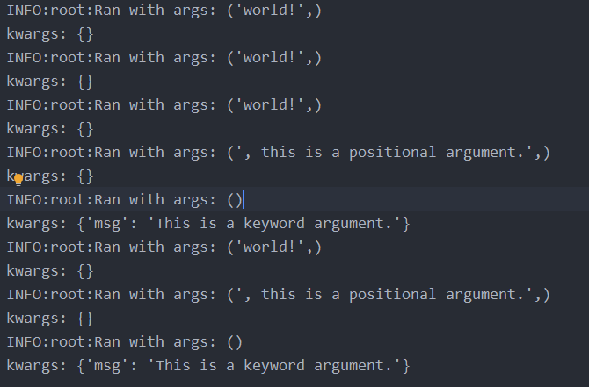

def my_timer(orig_func):  
 import time # Import time module  
 def wrapper(*args, **kwargs):  
 """We make a variable called to_be_timed otherwise we have to run the function  
 and that would print hello + {msg} again."""  
 t1 = time.time() # Get’s the current time  
 to_be_timed = orig_func(*args, **kwargs)   
 t2 = time.time() - t1 # t2 - t1 gives us the actual runtime of our function  
 print(f'{orig_func.__name__} ran in : {t2} sec')  
 return to_be_timed # We return our newly made variable  
 return wrapper  
  
@my_timer  
def hello_world(msg):  
 print(f'Hello {msg}!')  
  
hello_world('world')

## Chaining Decorators

We can apply more decorators to a function, and it’s as easy as stacking them upon each other but there is a catch:

@my_timer  
@logger_function  
def hello_world(msg):  
 print(f'Hello {msg}')  
  
  
hello_world('world!')

Stacking decorators this way is basically saying:

New_function = my_timer(logger_function(hello_world)) – which will give us some funny results

So in the upper example logger_function() returns wrapper and my_timer() gets __name__ from loggings inner function called wrapper thus we will get the following results.

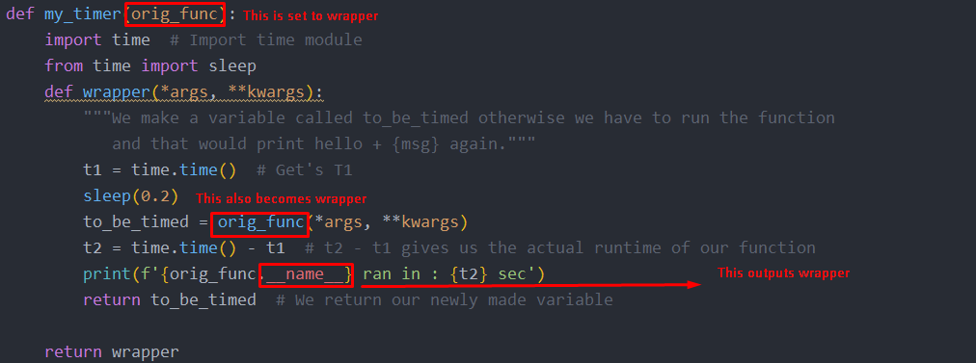

Hello world!

wrapper ran in : 0.20046329498291016 sec

We can see that we get : wrapper ran in instead of hello_world ran in xxxx seconds. That is because of this:

This is what happens when we do it the other way around.

@logger_function 🡪 logger_function(my_timer(hello_world))

@my_timer  
def hello_world(msg):  
 print(f'Hello {msg}')

Hello_world(‘world’)

Output:

Hello world!

hello_world ran in : 0.20046353340148926 sec

This time output looks ok but our logging_file name is wrapper.log instead of hello_world.log because of the same principle explained above.Gonna put another pictures since I might forget this when I visit this document years later (hopefully not).

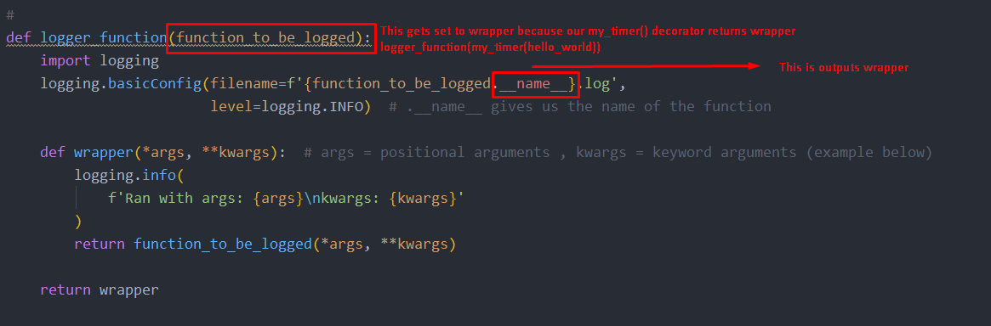

def my_timer(orig_func):  
 import time # Import time module  
 from time import sleep  
 def wrapper(*args, **kwargs): # We put this here because otherwise our it will raise an error since our orig_func() has args  
 """We make a variable called to_be_timed otherwise we have to run the function  
 and that would print hello + {msg} again."""  
 t1 = time.time() # Get's T1  
 sleep(0.2)  
 to_be_timed = orig_func(*args, **kwargs)  
 t2 = time.time() - t1 # t2 - t1 gives us the actual runtime of our function  
 print(f'{orig_func.__name__} ran in : {t2} sec')  
 return to_be_timed # We return our newly made variable  
  
 return wrapper

### The workaround

The workaround is very simple we just have to import wraps from the functools library and it fixes this.

from functools import wraps

After we import this we are going to wrap all our decorator arguments with this wraps() function

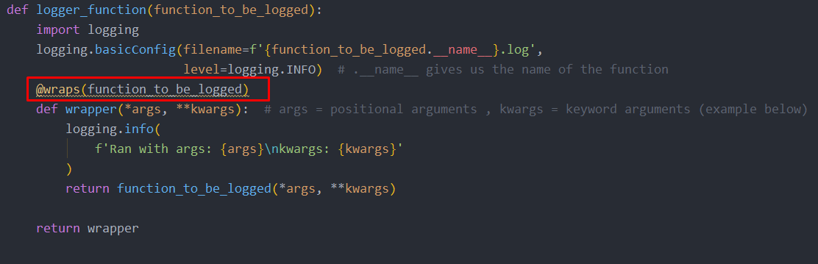

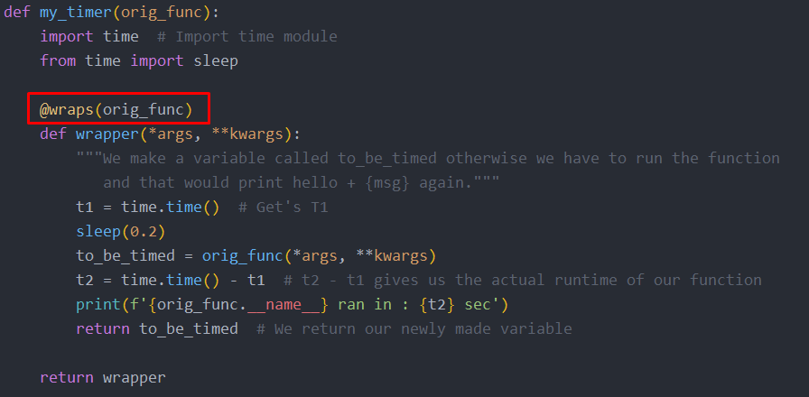

Don’t forget to add original_function into wraps like this!!!!

@wraps(orig_func)

After this the code should work like a charm.

# Doing decorators with classes

class decorator_class():  
  
 def __init__(self,original_function):  
 self.original_function = original_function  
  
 def __call__(self, *args, **kwargs):  
 print('The call method executed this before my_timer()')  
 return self.original_function(*args, **kwargs)  
  
@decorator_class  
def hello_world(msg):  
 print(f'Hello {msg}')  
  
hello_world('world!')